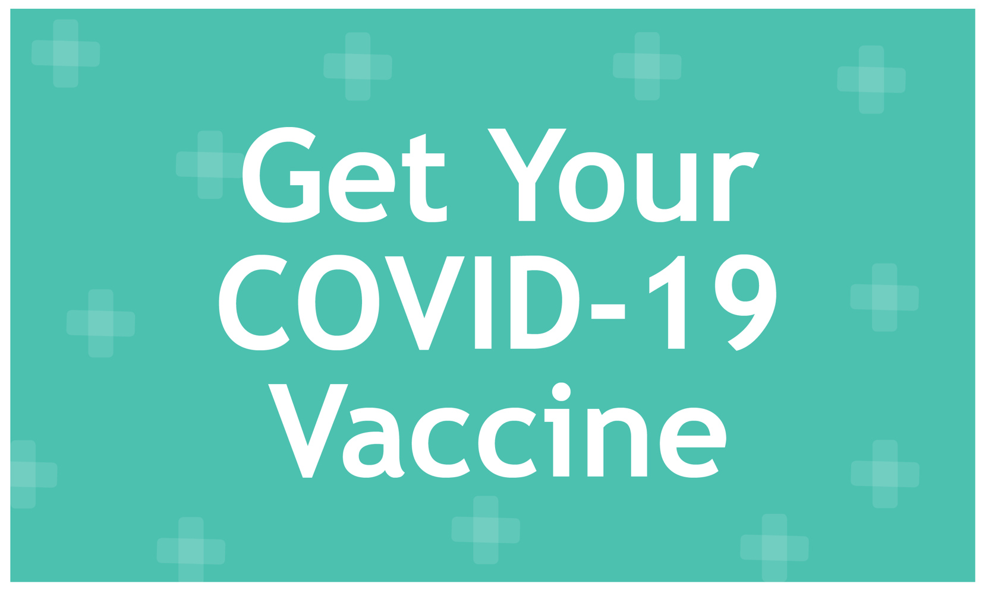

**Protect Yourself and Your Coworkers**

As part of our ongoing commitment to your health and well-being, we are hosting an on-site COVID-19 vaccination event. COVID-19 vaccinations will be administered by TotalWellness nurses. These trained healthcare professionals are dedicated to ensuring a safe and comfortable experience. Here’s everything you need to know:

**📅 Date:** [Insert Date]  
**🕒 Time:** [Insert Time]  
**📍 Location:** [Insert Location]

**Why Get Vaccinated?**

* **Protect Yourself:** Reduce your risk of severe illness from COVID-19.
* **Protect Others:** Help prevent the spread to your family, friends, and colleagues.
* **Community Safety:** Contribute to a safer and healthier workplace for everyone.
* **Convenience:** We bring the vaccine to you!

**Sign Up:** Register now at [Insert Link to Register My Time page].