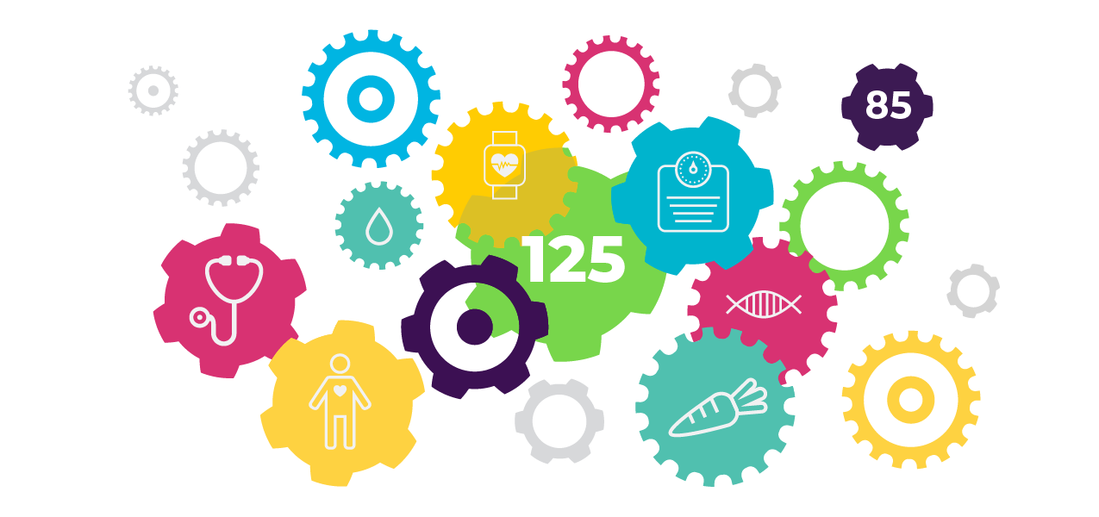

**Get The Whole Story**

*Get a Free Biometric Screening*

**Date | Time**

**Location**

At your biometric screening, you’ll receive a complete rundown of what your unique numbers mean and discover how to use them on your path to becoming healthier and happier. The screening will include blood pressure, BMI, cholesterol, glucose and waist circumference. Register here:

**Once you have these important numbers, you can:**

* Share it with your physician to address specific issues.
* Use it as an inspiration to make lifestyle changes.
* Celebrate the fact that you’re on the right track!

**Screening tips:**

* Glucose and cholesterol levels can be affected by eating before the screening. To ensure accuracy, we recommend that you avoid eating or drinking anything other than water nine hours before screening.
* Continue taking medications as prescribed; follow your doctor’s fasting advice.
* Wear short sleeves or loose-fitting shirts for blood pressure reading.
* Drink plenty of water before the screening to be well hydrated. It makes it easier to give a blood sample.

